AD-102: Petrol Solenoid Valve

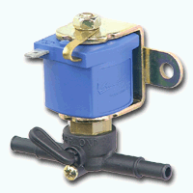
AD-102

Main features:

- high thermal induction coil wire to give virtually unlimited life
- provided with a self extinguishing coil covering resin
- high resistance to vibrations
- multiple fitting position
- very compact
- provided with a manual emergency device

