AD-100: LPG Solenoid Valve

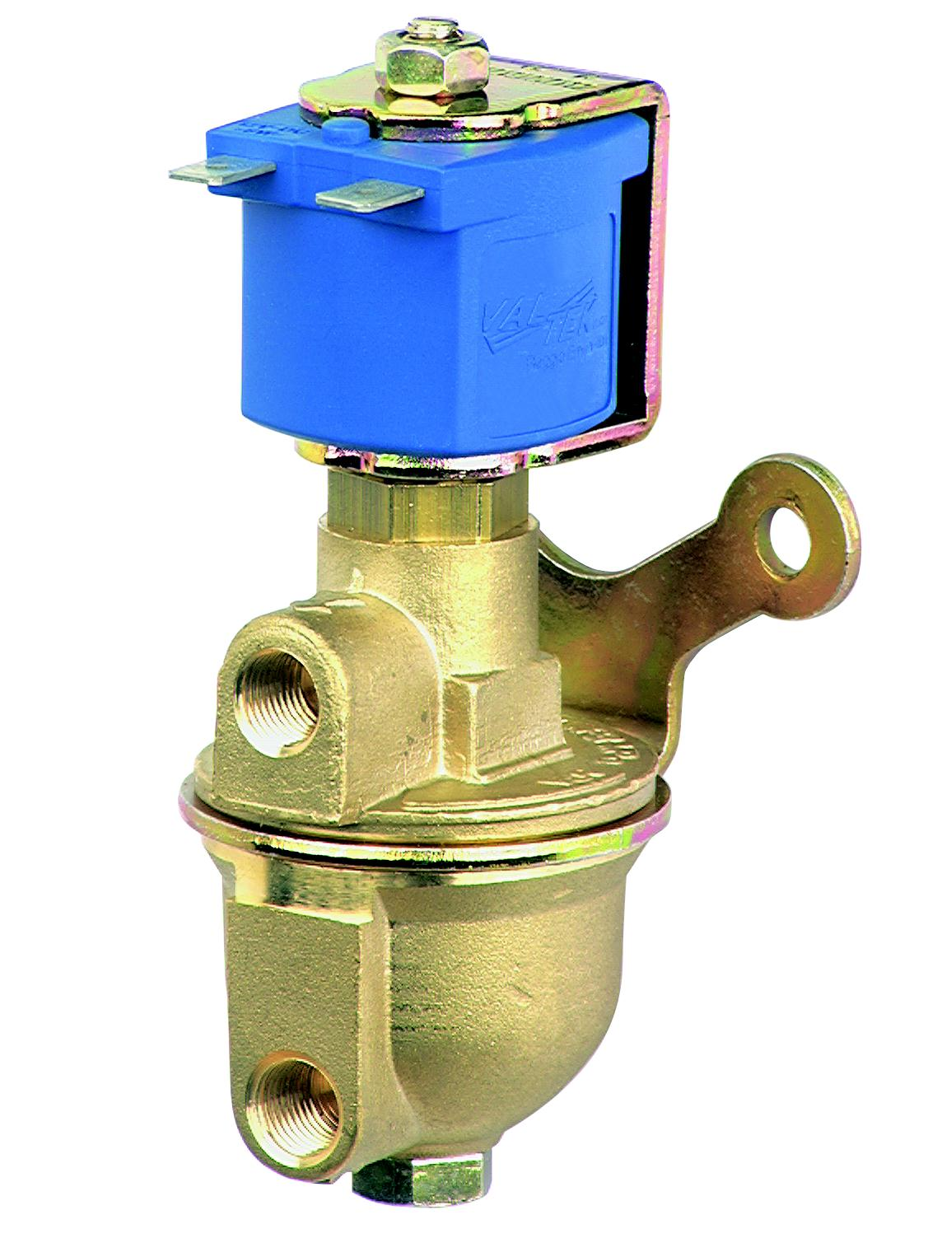
AD-100

Main features:

- NBR seals to guarantee absolute safety
- high thermal induction coil wire to give virtually unlimited life
- provided with a self extinguishing coil covering resin
- gas filter made with a fine filter paper material
- high resistance to vibrations
- multiple fitting position

